**Assignment – Airline Passengers**

Shaun Pritchard

Rasmussen College

QMB3200

Kimberly Powell

July,30 2020

**Assignment – Airline Passengers**

In this program Used MEAN to calculate the MIN, MAX, MEAN, and standard Deviation of the Airline passengers data set. I then sorted the data and used PROC MEAN to output the calculations with full titles and footnotes. Here is my code as in Assignment_AirlinePassengers_MOD4.sas.

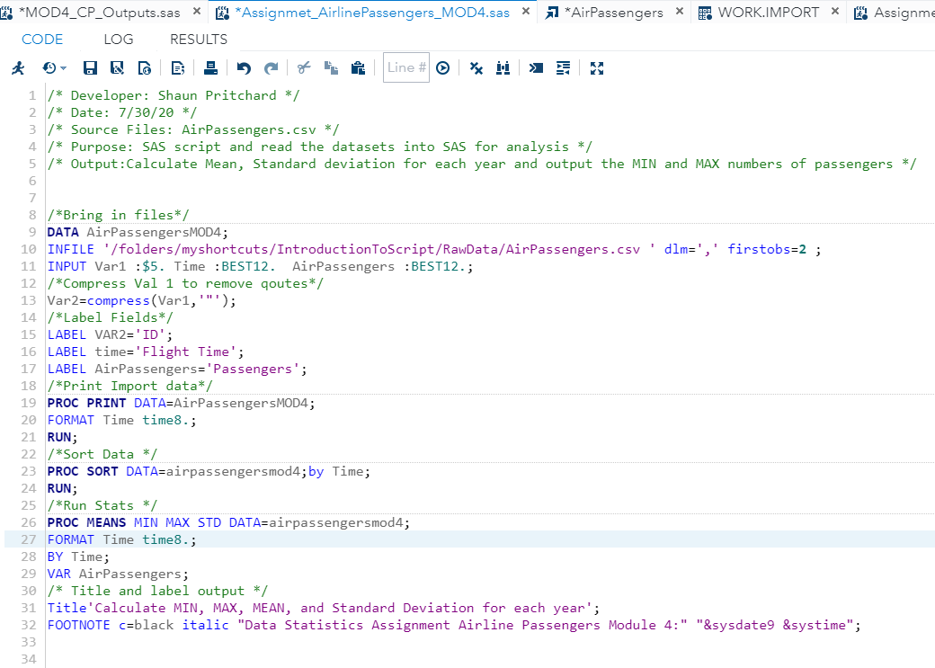

**Code Output:**

